In this network configuration, I have implemented Network Address Translation and Port Address Translation to enhance security and address management. I set up a pool of internet addresses with static NAT for a web server, Dynamic NAT/PAT is applied to hide internal hosts behind a shared internet address, facilitating internet access. I configured NAT on internal and external interfaces, ensuring proper traffic translation. Additionally, I established a connection to the ISP router (172.16.0.0/30), utilizing EIGRP to redistribute static routes for default route propagation. Tests were conducted successfully, and documentation includes ping results, NAT translations, and configurations for management review. These changes improve network efficiency, security, and accessibility while maintaining the existing physical network structu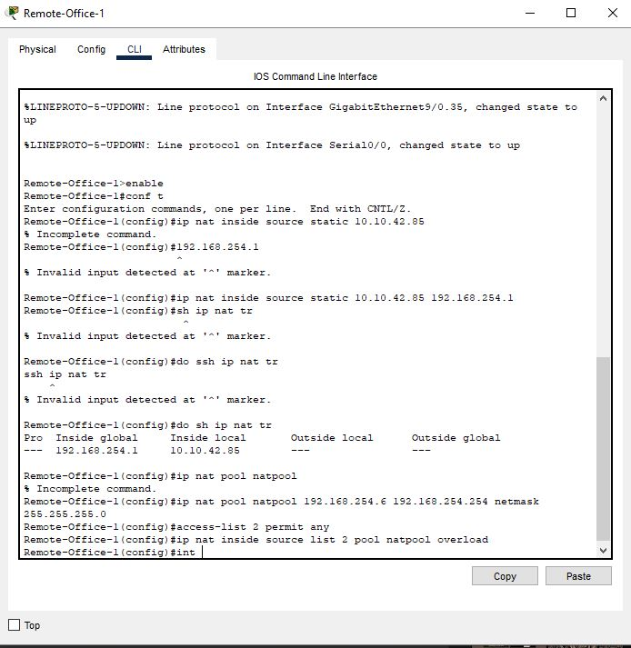re